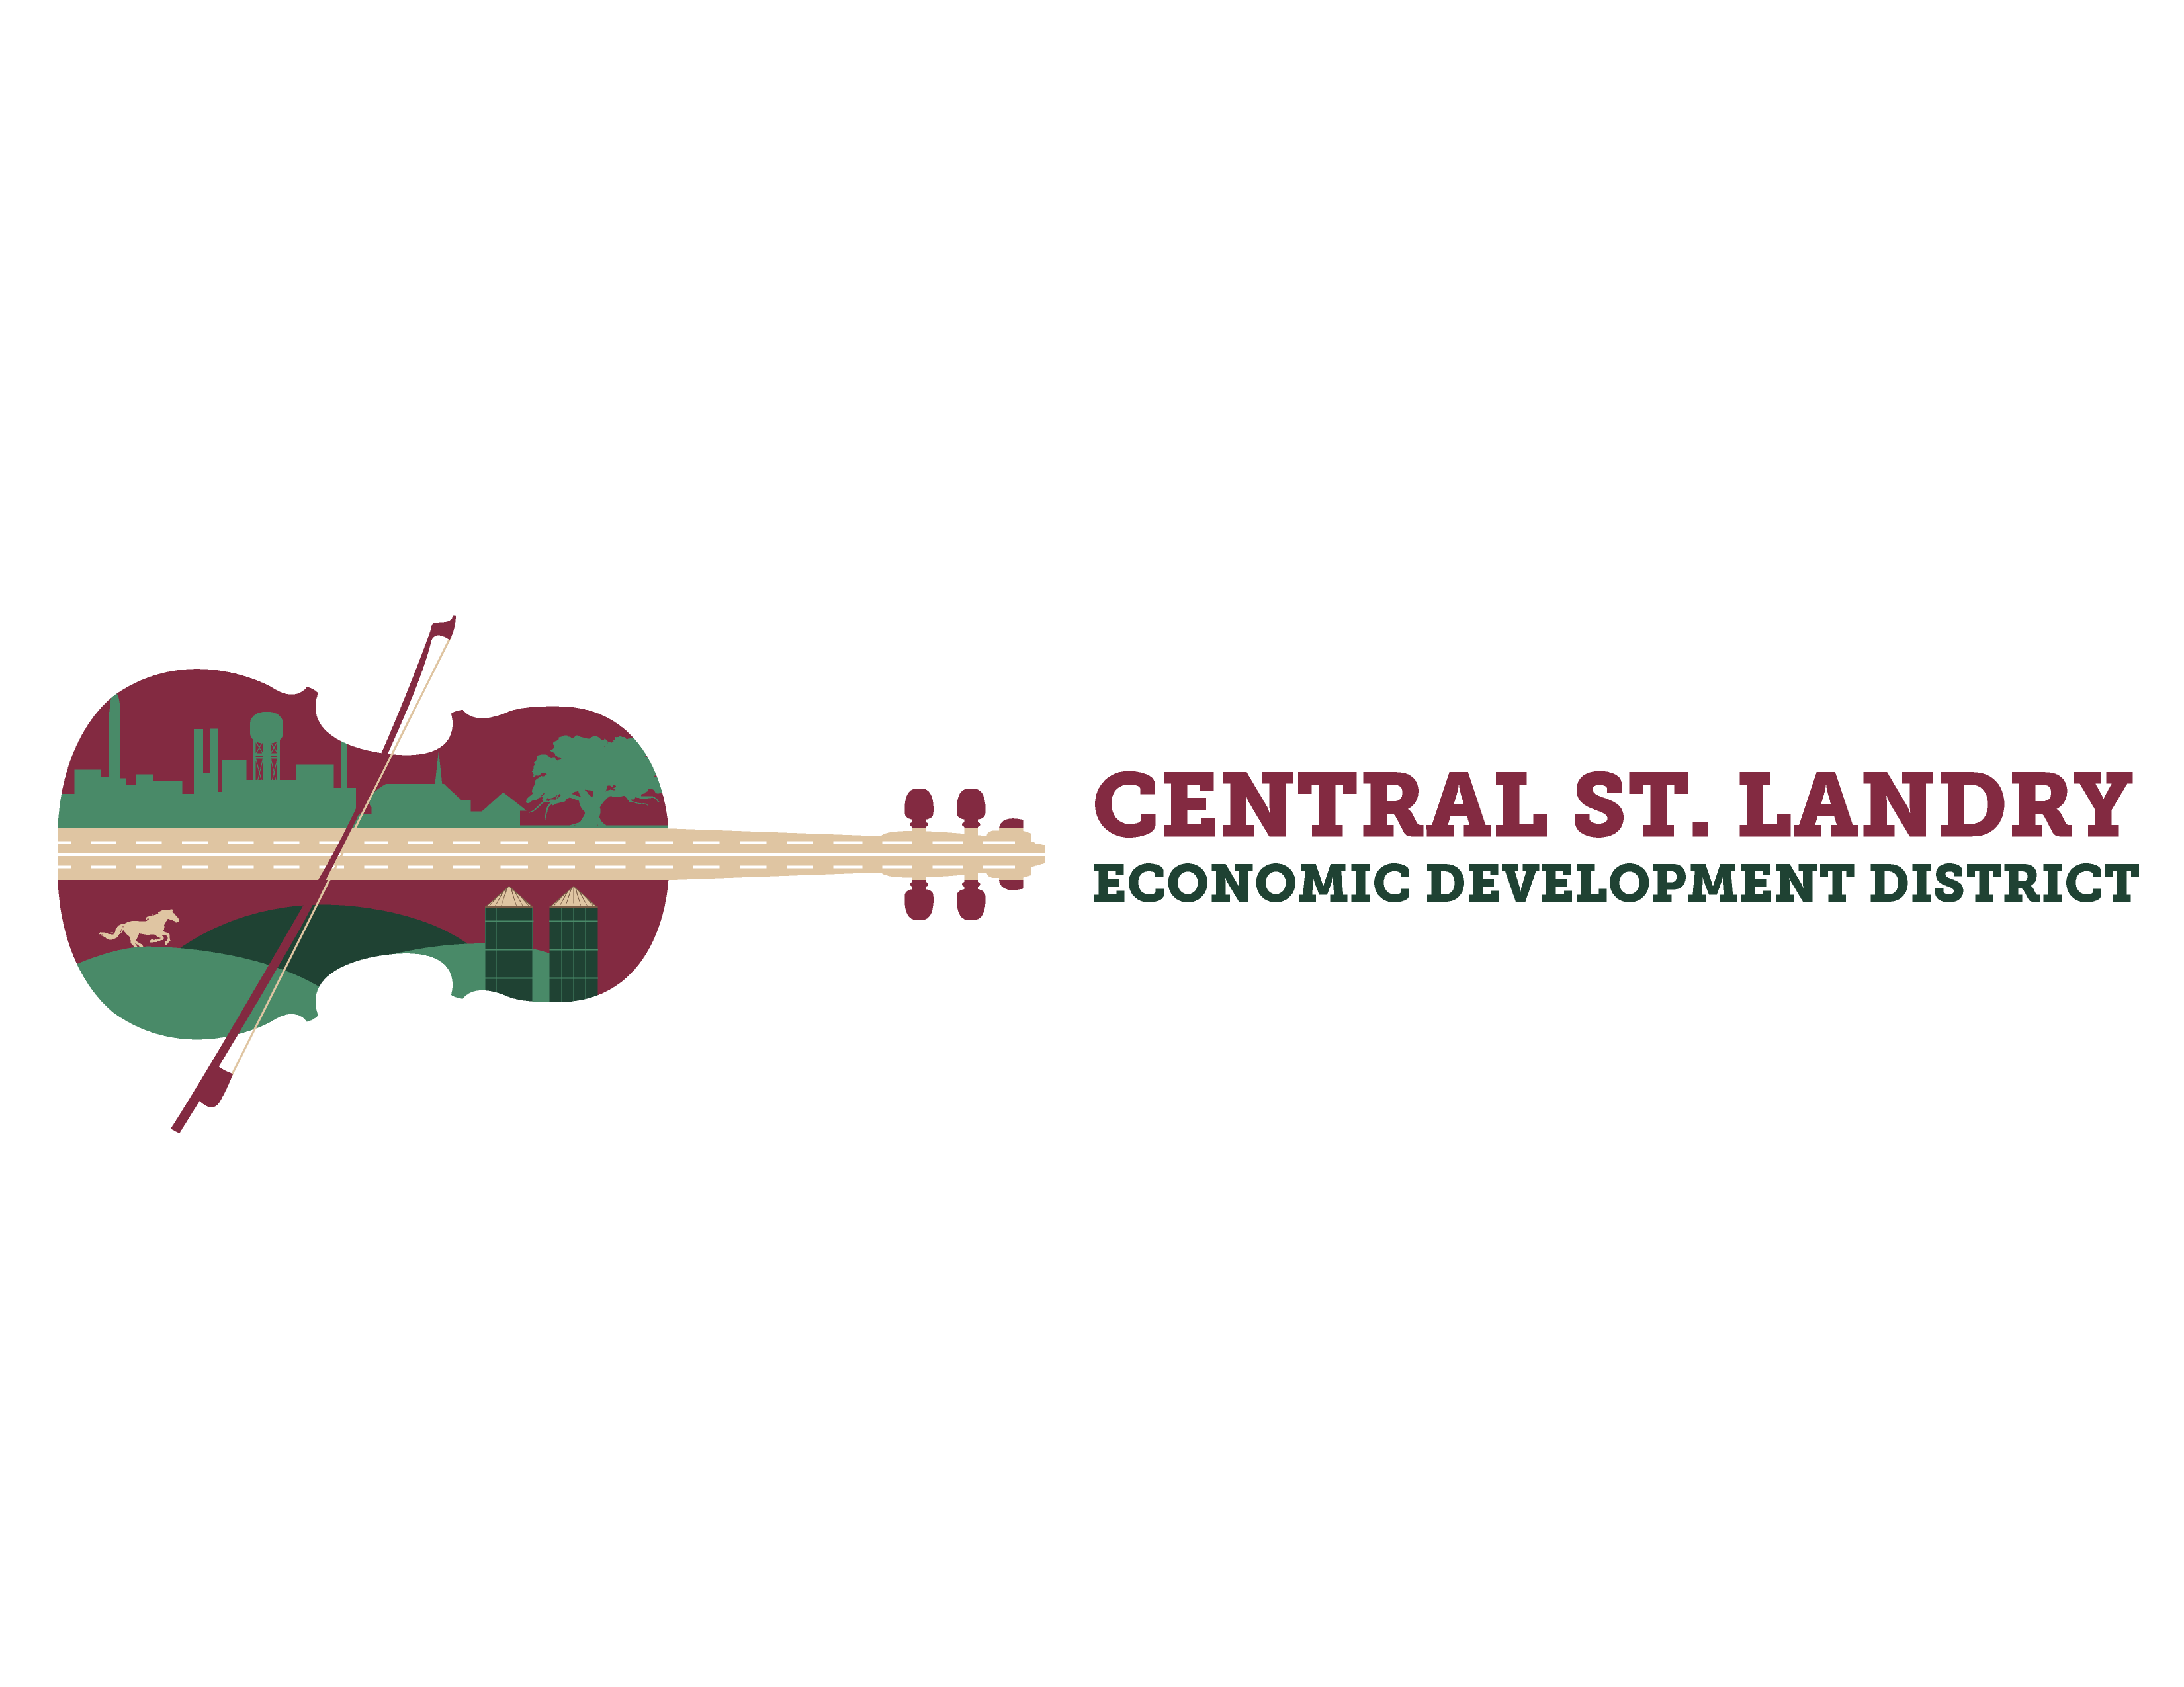
NOTICE OF PUBLIC MEETING
Meeting Date and Time: Thursday, January 9, 2025, at 8:30 am
Meeting Place: 5367 I-49 S. Service Road, Opelousas, LA

NOTICE IS HEREBY GIVEN that the Board of Commissioners of the Central St. Landry Economic Development District will meet in open and public session on Thursday, January 9, 2025, at eight thirty (8:30) a.m. This session will be located at the St. Landry Parish Economic and Industrial Development District office 5367 I-49 S. Service Rd., Opelousas, Louisiana, that such time the Board of Commissioners will hold a regular monthly meeting for the following purposes:

AGENDA
- Welcome

- Pledge

- Roll Call

- Public Comments – Limit of 3 minutes

- CSLEDD Business Recognition Program – Acadiana Pharmacy

- Approval of the December 12, 2024, Board Meeting Minutes

- December 2024, Financial Report

- Old Business
- I-49 Midway Corridor Update- Kade Jones (Acadiana Planning Commission)
- Equine Sales Facility Committee Update
- Retail Strategies

- Board Member Comments
The public and any interested parties are invited to attend. In accordance with the Americans with Disabilities Act, if you need special assistance, please contact Victoria Mott at 337-948-1391 describing the assistance that is necessary.
Upcoming Board Meetings:
- Tuesday, January 21, 2025, SLED Board Meeting, 10:00 AM
- Friday, January 24, 2025, ODDD Board Meeting, 9:00 AM
- Thursday, February 13, 2025, CSLEDD Board Meeting, 8:30 AM

