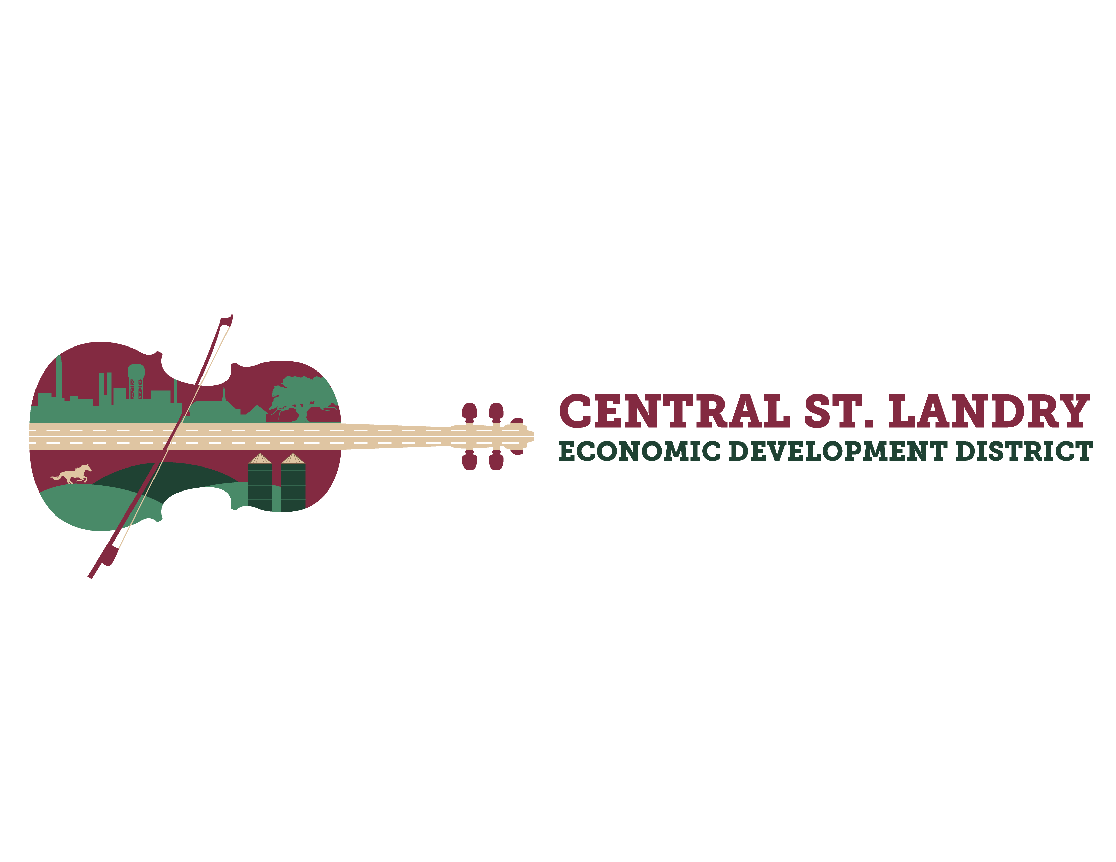
NOTICE OF PUBLIC MEETING
Meeting Date and Time: Thursday, February 13, 2025, at 8:30 am
Meeting Place: 5367 I-49 S. Service Road, Opelousas, LA

NOTICE IS HEREBY GIVEN that the Board of Commissioners of the Central St. Landry Economic Development District will meet in open and public session on Thursday, February 13, 2025, at eight thirty (8:30) a.m. This session will be located at the St. Landry Parish Economic and Industrial Development District office 5367 I-49 S. Service Rd., Opelousas, Louisiana, that such time the Board of Commissioners will hold a regular monthly meeting for the following purposes:

AGENDA
- Welcome

- Pledge

- Roll Call

- Public Comments – Limit of 3 minutes

- CSLEDD Business Recognition Program – Acadiana Hydrographics
1404 Jean Kayla Blvd
Opelousas, LA 70570

- Approval of January 9, 2025, Board Meeting Minutes

- January 2025, Financial Report

- Old Business
- Approval of Independent Audit Proposal by Vige, Tujague & Noel
- Wastewater Treatment Projects Updates
- Equine Sales Facility Committee Update
- Retail Strategies
- District Expansion

- Board Member Comments
The public and any interested parties are invited to attend. In accordance with the Americans with Disabilities Act, if you need special assistance, please contact Victoria Mott at 337-948-1391 describing the assistance that is necessary.
Upcoming Board Meetings:
- Tuesday, February 18, 2025, SLED Board Meeting, 10:00 AM
- Friday, February 21, 2025, ODDD Board Meeting, 9:00 AM
- Thursday, March 13, 2025, CSLEDD Board Meeting, 8:30 AM

